Programming Bootcamp 2016

Setup guide

Welcome to Programming Bootcamp! Before we start on September 6th, you will need to install Python v.2.7, Jupyter notebooks, and a plain text editor (*not* Word). This should be pretty straightforward, but I've included some instructions below to try and minimize problems. If you encounter a problem not addressed here, just post a question on our Piazza forum!

I. Opening a command line / terminal

For some parts of this guide, you will need to use the terminal (aka command line, command prompt, shell, console, etc). Here's how to open a terminal window, if you've never done it before:

**Windows:** Go to Start > All programs > Accessories > Command Prompt.

**OS X:** Go to Applications > Utilities > Terminal.

**Linux:** I'm going to assume you know what you're doing!

You might want to make a shortcut to your terminal for later, as you'll be using it a lot.

II. Downloading Python and Jupyter via Anaconda

[Python](https://www.python.org/), of course, is the language we’ll be using to learn to program. [Jupyter](http://jupyter.org/) is special kind of “notebook” editor for Python code. Jupyter is not at all necessary for using Python, but it’s very useful, and I’ll be using it a lot in this course. I’ll explain more about how to actually use these things later – for now, you just need to make sure that both are properly installed on your computer so that you can hit the ground running on day 1.

[Anaconda](https://www.continuum.io/anaconda-overview) is a package manager for Python (among other things). What this means is that it provides you with an easy way to install packages and handles things like dependencies and version conflicts. Don’t worry if that doesn’t mean much to you right now – **all we care about at this point is that Anaconda will provide us with both Python and the Jupyter notebook in one easy download** (unfortunately, it’s difficult to get Jupyter set up otherwise). Later on, we might touch on some of the cool other features that Anaconda provides.

Below, find the installation directions that most closely match your operating system.

**Windows 7**

1. If you already have Python installed, I recommend uninstalling it, unless you have some reason not to. (It’s fine if you don’t want to uninstall it; you will just have to do a little extra work at the end.)
   * To uninstall a program, go to Computer > Uninstall or Change a Program (at top near navigation bar).
2. Go to <https://www.continuum.io/downloads>
3. Scroll down, and download the Python **2.7** version installer
   * Make sure to pick 2.7, not 3.5!
4. Open the installer and follow the directions. Some notes:
   * I strongly recommend you check “Add Anaconda to my system PATH environment variable” when prompted. You don’t need to check “Register Anaconda as my default Python 2.7”, but you can if you want.
5. Once the installation is done, check that it worked by doing the following:
   * Open a new terminal window (if you already have one open, close it and re-open)
   * Type python
   * You should see the prompt change to >>>. (If it does not, then something went wrong during the installation. Please post on the forum and we’ll try to help you.)
   * Look at the lines above the >>>. This will tell you what version of python you’re using. It should say “Anaconda” somewhere in there. If it does not, follow the directions below.
   * If all looks good, then you’re done! Type exit().

You should see something like this if all went well:

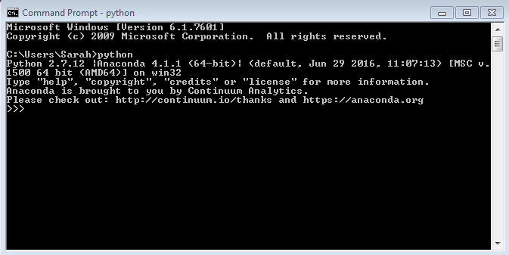

If you got the >>> but the version didn’t say Anaconda, then this probably means you already had Python installed, and that version is taking priority over the Anaconda version (this is what happened to me the first time). Here’s how to fix it:

1. We will need to edit the list of places your computer looks for commands (aka the “Path” variable). Go to where your Path variable is stored:
   1. Go to Computer > System Properties (at top near navigation bar) > Advanced System Settings
   2. In the “Advanced” tab, click “Environment Variables” (at bottom)
   3. In the “Systems variables” list (the second list, at the bottom), scroll down until you see a variable called “Path”. Highlight it and click “Edit”.
   4. Use your mouse or arrow keys to view the text in the “Variable value” field. You’ll see a bunch of paths separated by semicolons. Be very careful not to change anything, except for what I tell you to do below. (If you accidentally delete or change something, just click cancel and it should be fine.)
2. If you added Anaconda to your Path during installation, then at the end you should see some path(s) related to Anaconda.
   1. If you installed “for all users”, you should see the following THREE paths: C:\Anaconda2;C:\Anaconda2\Scripts;C:\Anaconda2\Library\bin
   2. If you installed only for current user, you will see ONE path that looks something like this (where “Sarah” is replaced with your name): C:\Users\Sarah\Anaconda
3. What we need to do is move these paths from the end of the Path to the beginning of the Path. Your computer searches the Path from beginning to end, so it’ll use the first version of Python it encounters. By putting the Anaconda paths first, we’ll ensure that is the version that is used.
4. To do this, carefully copy (or cut) all the Anaconda-related paths from the end of the Path. Move your cursor to the left until you’re at the beginning of the Path (or hit “Home” on your keyboard). Then paste the copied paths at the beginning. **IMPORTANT**: make sure to add a ; (semicolon) between the stuff you just pasted and the rest of the Path. You can also delete the semicolon at the very end after moving the paths. Here’s an example of what I did:

BEFORE:

C:\Windows\system32;C:\Windows;C:\Windows\System32\Wbem;C:\Windows\System32\WindowsPowerShell\v1.0\;C:\python27;C:\Program Files (x86)\ATI Technologies\ATI.ACE\Core-Static;C:\Program Files\MiKTeX 2.9\miktex\bin\x64\;C:\Anaconda2;C:\Anaconda2\Scripts;C:\Anaconda2\Library\bin

AFTER:

C:\Anaconda2;C:\Anaconda2\Scripts;C:\Anaconda2\Library\bin;C:\Windows\system32;C:\Windows;C:\Windows\System32\Wbem;C:\Windows\System32\WindowsPowerShell\v1.0\;C:\python27;C:\Program Files (x86)\ATI Technologies\ATI.ACE\Core-Static;C:\Program Files\MiKTeX 2.9\miktex\bin\x64\

1. Hit ok on all the windows. Close and re-open your command prompt, and type python. Make sure that it now says “Anaconda” somewhere in the version info. If it does not, double check that your Path was saved/looks right (check the semicolons), and/or post on the forum.

**Windows 8 / 10**

Unfortunately, I don’t have access to a computer with these operating systems at the moment. Try following the directions above, and if you encounter issues, let me know on the forum.

**OSX**

1. Don’t worry if you already have Python installed – it will still be on your computer; the Anaconda version will just take priority (and you can switch this later if needed).
2. Go to <https://www.continuum.io/downloads>
3. Scroll down, and download the Python **2.7** version installer for OSX
   * Make sure to pick 2.7, not 3.5!
4. Open the installer and follow the directions.
   * Keep the default settings if possible. It will add Anaconda to your PATH – this is what you want.
5. Once the installation is done, check that it worked by doing the following:
   * Open a new terminal window (if you already have one open, close it and re-open)
   * Type python
   * You should see the prompt change to >>>. (If it does not, then something went wrong during the installation. Please post on the forum and we’ll try to help you.)
   * Look at the lines above the >>>. This will tell you what version of python you’re using. It should say “Anaconda” somewhere in there. (If it does not, post on the forum and we’ll try to figure it out.)
   * If all looks good, then you’re done! Type exit() to go back to the command line.

You should see something like this if all went well:

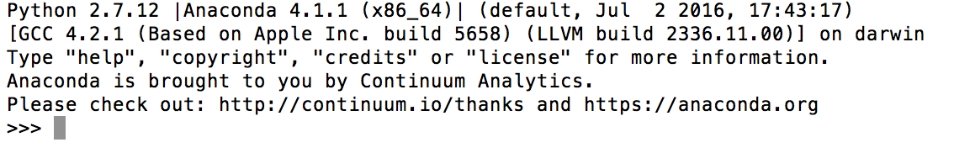

**Linux**

You should be able to mostly follow the OSX installation guide above (just make sure to choose the Linux installer when downloading). If Anaconda is not automatically added to your PATH, you may need to add it yourself by editing your .bash_profile file. I’m going to assume you generally know what you’re doing here, but feel free to post on the forum if you need assistance.

**Notes for all operating systems:**

* Antivirus warnings: You might get a warning from your anti-virus at some point about Anaconda. I promise you this is a legit program that is widely used in the Python community. So if your anti-virus complains, please tell it to allow this program.
* Download size: The Anaconda download is rather large because it comes with a bunch of Python packages. Many of these packages are very useful (for example, Numpy, Scipy, Pandas, Matplotlib, Jupyter notebooks), and in the long run you’ll probably be glad to have them. However, if the large download is a problem for you, you can instead download “Miniconda”, which is basically just Python + the basic Anaconda utilities (no extra packages). Just note that if you do this, you must manually add the Jupyter Notebook package. Follow the directions below:

1. Download Miniconda here: <http://conda.pydata.org/miniconda.html>
   * Choose Python 2.7 and your correct operating system.
2. Install and verify your installation as described in the regular instructions above.
3. **Add Jupyter:** Since this is a bare-bones install, it doesn’t come with Jupyter. Luckily, installing it will be easy, because one of the main purposes of Anaconda is to make installing packages easy! Just do the following:
   * Open the terminal
   * Type conda install jupyter
   * That’s it! You can do this with any other packages you need in the future, as well.

III. Installing a plain text editor

The final thing I’d like you to do is install a plain text editor. We will use this in addition to the Jupyter editor to write Python code. I’ll explain the differences between these two ways of writing code during the first lesson.

There are many plain text editors to choose from, but some make coding more pleasant than others. You cannot use Word to write code, as Word adds all kinds of invisible characters to your text that make it unreadable to Python. Instead, I recommend one of the following:

**Windows:** [Notepad++](http://notepad-plus-plus.org) . This is what I use. It's free.

**OS X:** [TextWrangler](http://www.barebones.com/products/textwrangler). This is what I used to use on Mac. If you're willing to pay a little money, there are some other options (google for recommendations).

You're welcome to explore other text editors if you wish. There are several that are specifically made for writing code (e.g. Eclipse) and may offer some nice extra features. There are also command line-based editors such as vim and emacs that many programmers use. These tools have a bit of a learning curve, and are not what I use personally, so I won't go over them during the course. Check them out if you're curious, though -- there are tons of tutorials online.